**Salahaddin University-Erbil College of Science Computer Science & IT Department**



**Salahaddin University   
Learning Management System**

A project Submitted to the Computer Science & IT Department Salahaddin University – Erbil In the Partial Fulfillment of the Requirement for the Degree of Bachelor of Science Computer Science & IT

**Prepared By:**

Malak Kamaran

Zina Mazin

**Supervised By:**

Mr. Shakhawan Hussein Mahmood

(2019-2020)

**Dedicated to :**

Our parents who are supporting us during this year, and to our supervisor Mr. Shakhawan Hussein Mahmood who helped us to complete this project.

**Certificate**

I certify that the project titled “***salahaddin university   
learning management system***" was done under my supervision at the Computer Science and IT Department, College of Science - Salahaddin University –Erbil. In the partial fulfillment of the requirement for the degree of Bachelor of Computer Science and IT.

Supervisor

Signature:

Name: Mr. Shakhawan Hussein Mahmood

Date: 00/00/2020

**Abstract**

An electronic way of learning and communicating with students offers a lot of advantages that can be achieved through different solutions. Among them, the most popular approach is the use of a learning management system.

Learning Management Systems are online platforms where teachers and students can collaborate in order to improve student achievement they allow teachers to create an online class, upload assignments, add resources for student to use both outside and inside of the classroom. LMS can help to grade those assignments and deliver quick, high-quality feedback and they allow teachers to communicate with student in a number of ways.

Essentially, Learning Management Systems allow teachers to organize and optimize their entire class method for students, the Learning Management System allows them to access their class online. They can find their assignments according to the dates they can find and use a wide variety of classroom resources, and they can even hand in assignment and show up-to-date grades.

**Table of Contents**

|  |  |
| --- | --- |
| **Chapter** | **Page** |
| Dedication  Certificate  Abstract  **Chapter One**  Introduction  1.1 Overview  1.2 History  1.3 Aim of the project  1.4 Objective of the Project  1.5 Features of learning management system  1.5.1 Admission of students to the institution  1.5.2 Availability of information from a single source  1.5.3 Easy-to-use simplified process  1.6 Related Work  1.6.1 Moodle  1.6.2 Edmodo    **Chapter Two**  Methodology  **Chapter Three**  Analysis and Design  **Chapter Four**  Conclusion  References  Appendix  پوختە | Ii  iii  iv  1  1  3  3 |

**Table of Figures**

|  |  |
| --- | --- |
| **Figure** | **Page** |
| Figure 1.  Figure 2. |  |

**Chapter One**

**Introduction**

* 1. **Overview**

Learning management System (LMS) is a web-based application software designed to introduce a helpful and structured information exchange environment for participating students, teachers and the administration of college. This software program systems enable educational establishments to control student-associated activities such as keeping records of tests or examinations conducted, attendance, , and all other association related activities; in short, they provide a whole student data system. They are designed with different application abilities reaching from simple management of students’ records at college to management of all student-related functions as well as administrative purposes of a university or a sequence of educational institutions. The Learning Management System goes far beyond conventional training by recording every training session, managing individual training requirements and reporting training progress. Most LMSs are Web-based and facilitate “anytime, anyplace, any pace” access to learning content and administration.

* 1. **History**

Much of the software used in beyond student information structures and college management worked on a nonoperational code base and had a curious combination of presentation, enterprise sense, and record accessibility. It was difficult and frequently highly-priced to regulate these structures to provide to future demands.

Some of the early creativity software programs together with WebCT, SCT Campus Pipeline, Jet speed, and Blackboard simply enabled interactions between students and teachers for academic purposes and served only as a student information system. The benefit of having a student management system was disappeared as it was not possible to combine any of the campus-based activities within these systems. Most often, student data were kept distributed in a couple of locations, making it hard to interpret and project.

* 1. Aim of LMS

Creating a secured LMS for Salahaddin University under the name “SULMS” which is an online platform where teachers and students can collaborate in order to improve student achievement.

* 1. Objective of LMS

The principal goal of Learning Management Systems is to enhance the learning process. A Learning Management System not only provide content, but also handles registering courses, course administration, skill gap analysis, tracking, and reporting. Most LMSs are web primarily based and are used in diverse instructional institutes.

The basic objective of Salahaddin university LMS are:

1. To create a login page in which user can login to and logout from this page successfully.
2. There will be three user roles that are Admin, Teacher and Student
3. The admin should have access to all parts of the system.
4. The teachers should be able to create courses, create assignments, and upload and download files.
5. The student should be able to view course materials, download files and submit assignments.
   1. **Feature of LMS**

**1.5.1 Admission of students to the institution**

Using an auto reply function and a standard format, a student system replies all the admission-related requests of students who may want to apply. Also, during the admission, the created database is used for sending admission letters or regret letters to the prospective students. During the registration of college students the machine stores all the main subject and optional subject details. This information is further used for automatic creation of subject classes and assignments to teachers.

**1.5.2 Availability of information from a single source**

Most of the student structures are created with a goal to save details of quality information and make them available as a combined system. Use of such online administrative and student systems increases the practical performance of an institution. Availability of a student records system covering all information details at a single source enables easy categorization of the right information.

**1.5.3 Easy-to-use simplified process**

The student system enables assembling of all the statistics at a single source, especially that of students and teachers. This electronic storage of statistics cuts down the usage of paper at all levels. Such an availability of all the required information in the electronic form facilitates easy recovery, and also speeds up approval procedures. It is possible to keep all student-related activities such as test performance, and examination schedules in the system.

* 1. **Related work**
     1. **Moodle**

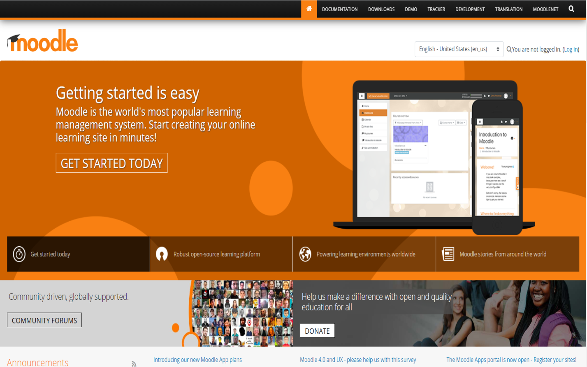Moodle is the worlds most famous and most used Learning Management System LMS, Because Moodle LMS is a flexible, open source, and free to download learning management solution. With 68 million users and 55,000 Moodle sites deployed worldwide, Moodle is a user-friendly eLearning platform that serves the education and training needs of human being from all types of organizations.

**Figure (1.2) home page screen of moodle**

**The Advantages Of Moodle:**

Online studying and continued education opportunities in any place, time and situation.

**Moodle is Supported by a Global Community**

Moodle is supported by using a global community of builders. A large advantage of open source software is that the code is open for scrutiny. This way that developers from all over the world can get right of entry to the code and alter it so that it is more secure.

* + 1. **Edmodo**

Edmodo is an educational network which provides teachers with tools to help them connect and communicate with their students and parents. Via the Edmodo app or website, teachers can share content, texts, videos, homework and assignments with their students online.

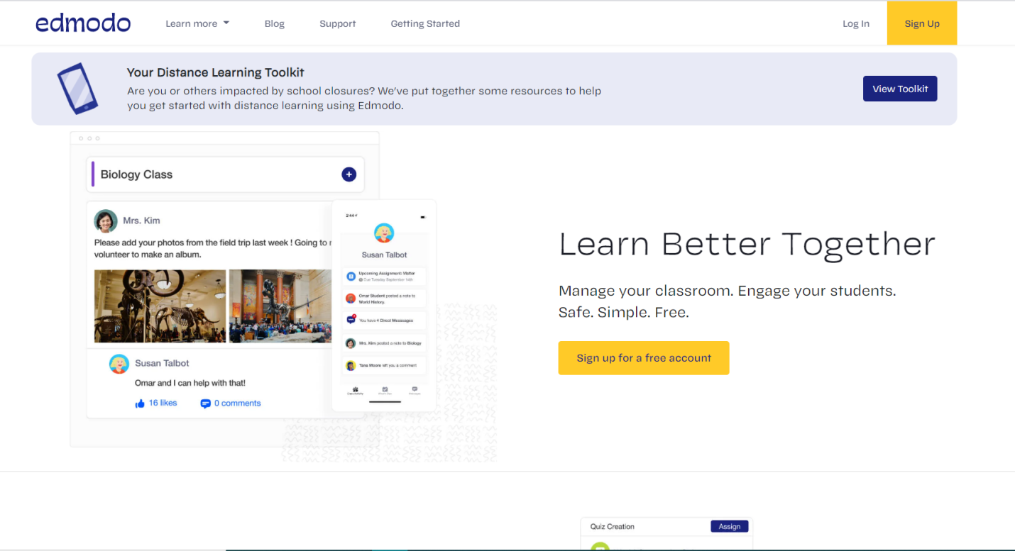

**Advantages of Edmodo**

Edmodo has many features that let students to access class information quickly. Teachers are able to respond online through the site to the students and to their parents.

**Disadvantage of Edmodo**

Edmodo is a social networking internet site. Teachers, students and parents may use the site incorrectly. Another disadvantage is access to the internet. If this site is going to be used for assignments or announcements, all students must have access to the site at home.

* 1. **Advantage and disadvantage of LMS**

• **It’s cheaper**: students can learn with any linked device that is connected to the Internet. There’s no need to rent a building or pay for high-priced utility bills that are required to provide students with a learning facility. In addition, students and teachers will no longer attend to class, and that saves their money as well!

• **Access to course material is at anytime**: Course material is up to date and students can see the changes made in the particular field.

• **It takes much less time**: The teacher doesn’t need to give the same class repeatedly to different groups of students.

• **It allows for self-paced studying**: Students can take courses from their own devices anytime and anywhere they want.

• **It’s modern**: Most people today prefer to consume content using the Internet.

• It’s a **motivation** to learners, provide feedback and support during the learning process.

**Disadvantage of learning management syatem**

• **Plagiarism**: Keeping in mind that students are using a PC and not being watched at all times, they could potentially plagiarize essays and other assignments.

• **Cheating**: it can be easier for students to cheat on online exams.

• **Isolation:** Since students are not physically in a classroom, it might be more difficult for them to contact the other learners.

Project diagram and sequence

**Chapter Two**

**Methodology**

In computing, a website is a client server computer program which allows the client to run in internet browser. Here we going to explain greater approximately what are the user needs, and we're here to answer that question with more details, our goal is to create an easy interface for the user creating a website with comfortable feature so using other website because other websites are hard to use and not responsive with the user that makes it hard to use. In addition, we desire to provide additional capability for managing and friendly for user.

**2.1 Technical Tools**

**1 HTML:** is the markuplanguage that we need to implement the structure of our pages and HTML5 is the latest version [1]



**Figure** HTML Logo

**2 CSS** (Cascading style sheets) : is the styling language that we use it to style the markup language and we use latest version is CSS3[2], and in our website we use bootstrap 4 which is a CSS framework that make the over CSS work easier to implement [2].



**FIGURE** CSS Logo

**3 JavaScript:** is the scripting language for web pages and its lightweight and interpreted language that we need it to make dynamic pages , and also its useful to make the process faster as its working on client side . we put some process there which is not necessary to be done in the server side . [3]



**Figure** JavaScript Logo

**4 PHP :** Server side programming language that is specially made for web developer and its open source general purpose scripting language , current version (php7) . we use it as server side for the main functionality of our project .



**Figure** PHP Logo

**5 MYSQL :** is a relation database management language which is open source and free , we use MYSQL as a database management



**Figure** MYSQL DataBase Logo

**2.2 data base**

SULMS data base is done by MYSQL the data is stored separately in deferent table and managed by both MYSQL and PHP to provide it on the page.

**2.2 DataBase**

Salahaddin University learning management system is done by MYSQL, the data is stored separately in different table and managmed by both MYSQL and PHP to provide it on the pages, MYSQL is relation databse and the table can have relation by foreign key constraint .

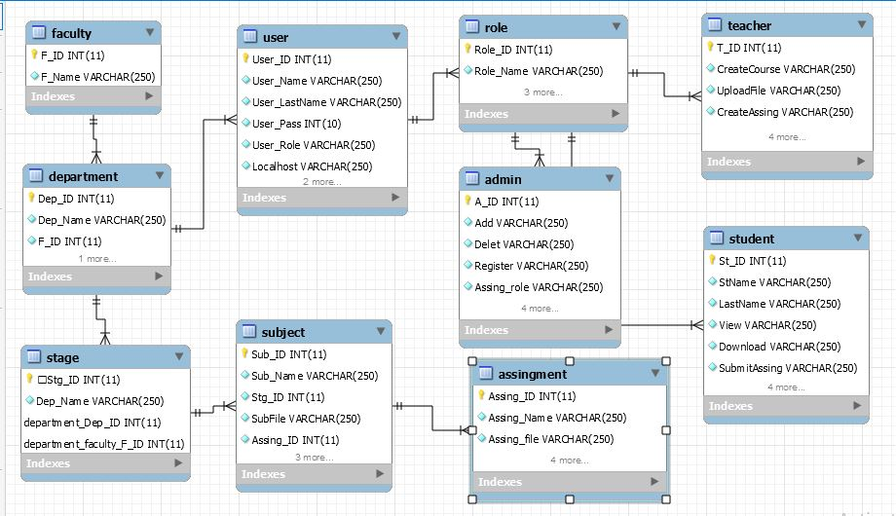

**Figure 2.3 Database Tables**

**Chapter Three**

**Analysis and Design**

How the project works with screenshots.

Limitation of the project and future works.

**3.1 interface page**

For the interface we used HTML structure language band CSS as designed two language. When we click on the home button a page opens which shows all the faculty within the university and only admin can add, remove or edit the faculties. And here we will work on college of science, computer science (CS) department.

**3.2 Login page**

In the page user will open as a member account when it's needed, the users are (Admin, teacher, student)

**3.3 admin page**

In the admin page we have some buttons, each of them are assigned to a specific actionwhich are listed below:

1. Add college
2. Add department
3. Add user
4. Show college

1. Show user
2. Show department
3. Teacher subject

**3.4 Teacher page**

In this page the teacher have control to put assignment, homework, files and quizzes for students.

**3.5 Student page**

**Chapter Four**

**Conclusion**

Conclusion of the entire project (between 300 – 500 words)

**References**

Arranged alphabetically by the author’s surname

**Appendix (if exists)**

(Any extra figures or code segments)

**پوختە**

(Translation of the abstract)